The Fourth Wilshaw Welly Walk All Routes 2.8 mile Red Text 5 mile RED and BLACK TEXT 8 mile Red, Black and blue text
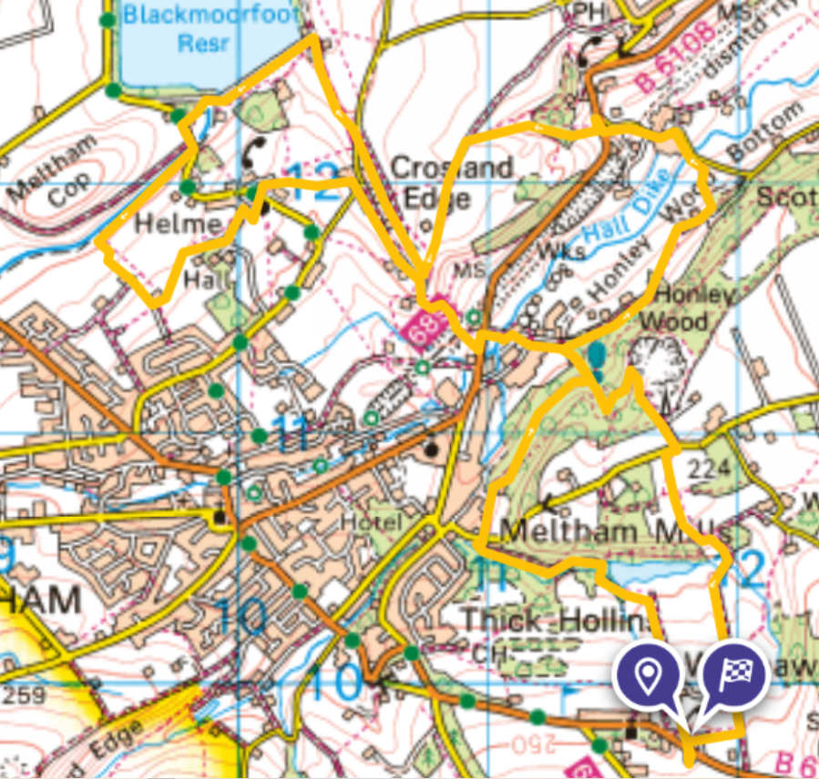
From the Village Hall cross the road and walk through St Marys court. Past the last house turn sharply left and walk down the footpath leading to Lower Greave. AFTER A VERY SHORT SECTION FACING TRAFFIC ON THE ROAD turn into lower Greave at our grade 2 listed phonebox, follow the lane then straight across the farmyard and down the footpath to Meltham Mills Reservoir built 1805. Home to Windybank Fly fishing club. Trout are often seen as you cross the bridge and continue across the reservoir banking. Turn left at the end of the embankment, and follow the lane all the way to the road.
1
1
7
3
4
3
CROSS THE ROAD and take the bridleway just below Lu’s Place café leading into the White Rose Forest/ Honley Woods (formerly known as Greasy Slack Wood). 150 metres or so after the path begins climbing uphill turn left where the path splits. After a while you will see the vehicle dismantlers site below on your left and immediately past this the route splits. For the 5 and 8 mile route turn left here down a wide path. To continue on the 2.8 mile short route turn right here (uphill) and skip to the next Red directions, overleaf.
Refreshment Point
This downhill path leads to a tarmac lane, turn right and follow the lane into the wood. Pass a few houses and the lane turns into an unsurfaced track. At the end of this track, past some old vehicles, turn down left for 20 metres then turn right and take the stile into the field, the path crosses grassland, then becomes wooded until it reaches more houses. PAY ATTENTION HERE. Shortly after passing the second property and just as the track turns to cobbles turn left on a grass path with the boundary wall on your left and continue into some woodland. Just after a stone stile take the path down to the left, it will join the driveway to a secluded house in the woods, continue to the road and then CAREFULLY FOLLOW THE ROAD down past a factory and then sharp left and uphill. After the housing estates just past the remains of the old railway bridge there will be a refreshment point. If you take the footpath to your right here for 150 metres along a short dead end section of the Meltham railway trail there are a few picnic benches.
After your break return to the road and walk up to Huddersfield Road. Very carefully CROSS THE MINOR ROAD to the bus stop then CROSS THE MAIN ROAD and climb the uphill path through the wood past a pond to your right. Continue uphill past various junctions into fields where it continues to climb uphill. After the second field the path continues on a track to the left. Note the fabulous views developing with Wilshaw in the distance. At the end of the track turn left and the footpath diagonally crosses a large field. Head towards the bottom right-hand corner towards a large housing estate in the distance, then towards the right of a hay barn and through a narrow pedestrian gate which is to the right of a metal farm gate. Cross the farm track and through another pedestrian gate, into a field, keep left through the field and go through another gate into scrubland. The path soon joins a narrow lane (5mile route directions continue in black after the blue text).
8 MILE ROUTE ONLY, turn right here and follow the lane keeping right for almost half a mile to a minor road. Carefully cross the road and follow the footpath all the way to Blackmoorfoot reservoir. Turn left and walk across the reservoir embankment. At the end of the embankment turn into the top of a lane on the left leading down to Orangewood and take the path immediately on the right that runs along the left side of the Blackmoorfoot conduit (watercourse) then carefully cross the road and continue along the left of the conduit with Meltham Cop appearing on your right. After three or four hundred metres take the first footpath on your left through an opening in the wall which immediately turns right and then left and continues through a field of newly planted trees. Follow the path gently downhill to a white painted farmhouse where you turn sharply left towards Helme Hall (built in 1887 and now a care home) which you will pass on your right. This path turns into an unsurfaced farm lane leading into Helme. When the lane turns sharply left continue straight along a footpath. When the path reaches a quiet lane turn right and walk into Helme Church grounds. Take the path to the left running along the top side of the church and CAREFULLY cross straight across the road onto another footpath. Turn right onto a gravel lane and then just before a small farm yard take the footpath to the right indicated by a yellow arrow. Just past a couple of low old stone gateposts take the right fork in the path on the left side of a row of oak trees. You should be heading slightly to the right of a vineyard on the hillside in front of you. Pass through an old stile and across a small stream then follow the path uphill towards some houses where you will join Harrison Lane. CAREFULLY TURN RIGHT and immediately left onto Crosland Edge. Follow this quiet country lane to the entrance to Lower Edge Farm where the track splits. Take the second track on the left along the topside of the Old Barn. Continue until you see the sign on your left announcing High Brow Farm, turn right here and you are rejoining the 5mile route. Follow downhill ignoring a lane joining from the right,(this is where the 8 mile route rejoins) and ignore footpath signs to the left. Just as the tarmac lane bends sharply right take the wide footpath to your left into the wood and then take the first path on your right just before the first field and by an old heavy wooden post. This narrow little used path passes under the Meltham Railway Trail into a new housing estate and then onto Huddersfield Road.
CAREFULLY CROSS HUDDERSFIELD ROAD and turn left towards Huddersfield. After a short distance follow the footpath down over the river (Hall Dike) and past our fragrant Sewerage Works (sorry). Turn left onto the narrow road, walk past the tip and the scrapyard entrance, though the no entry signs and after about 40 metres turn right up the same footpath you descended earlier back into the forest. Cross the main path, where you turned down earlier, and continue steeply straight up and at the top take the steep footpath to your left. There are many paths in this wood so follow the major track climbing uphill, after a few hundred metres take a slightly narrower path uphill to the right, as it begins to level off then keep right and you will join the wide track leading through the top of the forest. Follow this to the right and out of the forest and up to Meltham Road. Turn right and walk a short distance facing the traffic until you see the footpath sign across the road. CAREFULLY CROSS and follow the path across the field to a post, turn right for about 40 metres and then left over another stile into the fields and follow the path downhill. At the bottom cross another stile and take the left path a short distance then turn right on a stony and later concrete track back towards Wilshaw. Follow this track and take the second footpath sign on the right straight across a field (below the bungalow like Bell House Care Home) into St Mary’s Court where you turn left and CAREFULLY CROSS THE ROAD to the Village Hall for some well earned refreshments.

All routes are predominantly on public footpaths or very quiet lanes but occasionally cross busier roads, surfaces may be uneven and contain some steep sections.
There are no Marshalls on route and all walkers take part at their own risk and are advised to not attempt any route that may be too challenging for them.
If you get lost or need any assistance on route Phone Peter on 07952 671234 and we will do our best to help.

