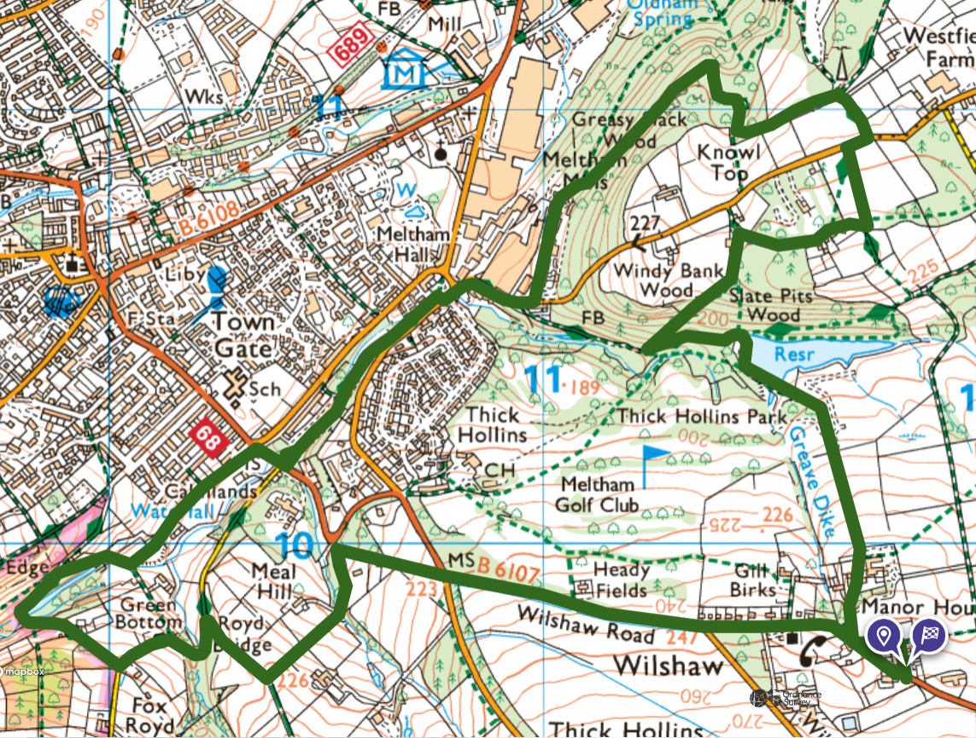
The Third Wilshaw Welly Walk Std Route 5miles
2
2
From the Village Hall (built 1873 at a cost of £1200) cross the road into St Marys court. Past the last house turn sharply left and walk down the footpath leading to the entrance to Lower Greave. SHORT SECTION FACING TRAFFIC ON THE ROAD Walk through lower Greave, (past our grade 2 listed phonebox) and continue straight across the farmyard and down the footpath leading to Meltham Mills Reservoir, built 1805, and aka Windy Bank.
1
1
1
Look out for trout as you cross the bridge and then walk across the reservoir banking. Turn left at the far end of the embankment, and continue down the lane for a few hundred metres. Just before it bends right and you see a black bin Turn right and follow the diagonal path up the hillside. It crosses an exciting mountain biking track but continue walking straight ahead and keeping left (the footpath becomes very faint here) until you reach farm buildings and a narrow farm lane (1) Turn right and follow the lane. You will shortly find two houses and a sign saying ‘no thoroughfare and no loitering’ Continue along, past the houses, keeping to the left and at the end of the lane the footpath continues and leads into a field. Keep right until you see another footpath and then turn sharp left across the field and follow the path towards Meltham road.
6 6
5 55
4
3
7
3
4
3
CROSS THE ROAD AND WALK ABOUT 50m TO THE RIGHT before turning down the tarmac lane leading towards Honley Woods or what is now known as the White Rose Forest. Take the first pathway to the left (2) into the forest and follow the main path until you eventually reach the bottom of the steep hill (Knowl) just above Meltham Mills Industrial Estate. (3) Note the newly opened Lu’s place café on the left as you meet the road.
6
5
CROSS THE ROAD HERE and walk down the hill. At the road junction CROSS THE ROAD and enter Meltham People’s Pleasure Grounds. (This is a scenic wooded park laid out by celebrated Landscape Gardener Joshua Major in 1885. It was privately owned and financed by Charles Brook a kind hearted textile millowner for his 2000 employees to use in their leisure time) Continue up through the park, now lovingly tended for by volunteers, until you reach the picnic area where you may want some refreshments. (4) There are some fairy houses on trees near the path in this park how many can you find?
After leaving the Park CAREFULLY CROSS THE ROAD and turn right towards Meltham. Take the first turn on your left which is a quiet level road overlooking a large newly built house on the left. Continue to the end and turn right up a footpath climbing past the site of an old mill. At the top and just in front of a bungalow the footpath continues to the left. This area is known as Royd Edge. Follow the path gently downwards (observing part of the old mill dam on the left) to the bottom and then turn left and cross a bridge. The rocky path climbs steeply (5) (If you are following the long route turn the page now). The std route continues up here and follows the track as it passes a few houses and stables and leads to a road. TURN LEFT AND FOLLOW THE NARROW ROAD DOWNHILL, passing a few more houses, until you reach a wide unmade bridleway on your right. Follow this bridleway and take the first footpath to your left this is near (6) on the map. FOLLOW UNTIL YOU REACH THE ROAD & TURN IMMEDIATELY RIGHT UP THE HILL AND THEN CROSS THE MAIN ROAD WITH CARE. Follow it all the way back to the Village Hall for some well-earned refreshments.
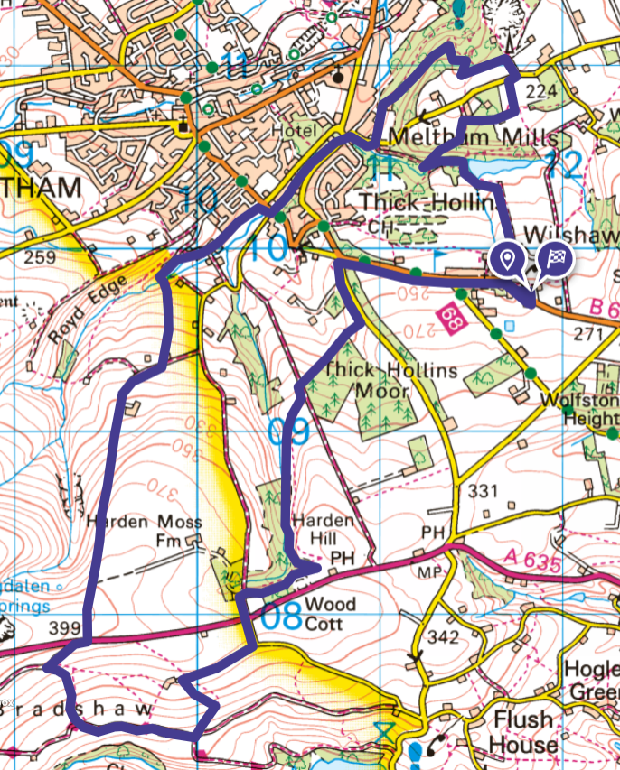
The Third Wilshaw Welly Walk Long Route 8 miles
This is a tough hilly route with some high stiles. Not suitable for most dogs and unfit humans! It is a great walk, very scenic and extremely varied. There are a few dodgy stiles and little bridges, some sections now have high bracken and there is one short potentially wet area so please be careful.
Follow the std route on the previous page and shortly after crossing the bridge near (5) take the wooden steps on the right that climb steeply uphill and climb over the high stile into the Woodland Trust wood (too recent to appear on the map). Follow the path straight up through the wood and eventually into a field. Be careful there is often an electric fence on one side of the path here. Follow the path until it joins a farm track (6) and turn right. Follow this track a few hundred metres and take the footpath that continues straight ahead in the middle of a bend just before the entrance to Ash Royd Farm. This is a long uphill stony section alongside an attractive moorland valley. Continue straight ahead over the crest of the hill and you will meet the main A635 Greenfield Road.
555
6
CAREFULLY CROSS THE A635 and walk about 50m to the right taking in the moorland view including Holme Moss. Follow the well signposted bridleway for about 150m until the track turns to the right. Look very carefully for a small footpath sign where the path turns sharply left and follow this narrow partially crushed stone path downhill until you re-join the main bridleway (7) and follow this to the left. You will eventually pass through a metal gate across the track, and then pass two disused farm buildings on the right. Shortly after this a wide lane branches off to the right BUT virtually opposite take the footpath uphill to the left (8). From the top of the stile you can see Digley reservoir to your right. Follow this path uphill until you reach a remote farm. Look out for the goats in the field on your left. Turn right here and follow the level farm track until you reach a quiet road. If the gate is closed climb the stone steps at the right side of the track and then turn and follow the road back to the A635.
8
7
9
CAREFULLY CROSS THE A635 and follow the lane opposite for about 150m, then take a narrow footpath on the right (9) through an old wood but take care throughout this section as the stiles are unsafe. You will pass in front of two new houses being built on the right and then an old shooting Lodge ‘Wood Cottage’. The path eventually leaves the wood and enters a field. You can see the Huntsman pub ahead but turn left now and follow the path down. After a few hundred yards and before it starts to go uphill head for the bottom corner of the field and cross a stile over the drystone wall leading into the wood again. Follow the path keeping the steep sided valley to your left. There is a short section in here that can be very wet, carefully make your way across or down the steep bank to a wider level track. Continue forwards and over a stile out of the wood to a well-defined track eventually leading to another stile into a large field. Over this stile the path is virtually invisible but cross this field diagonally and go over the stile leading onto a major rough track. Turn left for a short distance and take the first footpath on your right which runs along the bottom side of a young woodland. Follow the edge of this woodland and then the same fenceline until you see the main road. Stay in the field and turn left walking parallel to the road until you reach a stile leading to the road and a private drive. CROSS THE ROAD HERE AND WALK VERY CAREFULLY DOWNHILL facing the oncoming traffic until you can turn right onto the footpath on Wilshaw Road. Follow this road back into Wilshaw and until you reach the Village Hall and some well earned refreshments and a rest. WELL DONE Any problems phone 07952 671234

