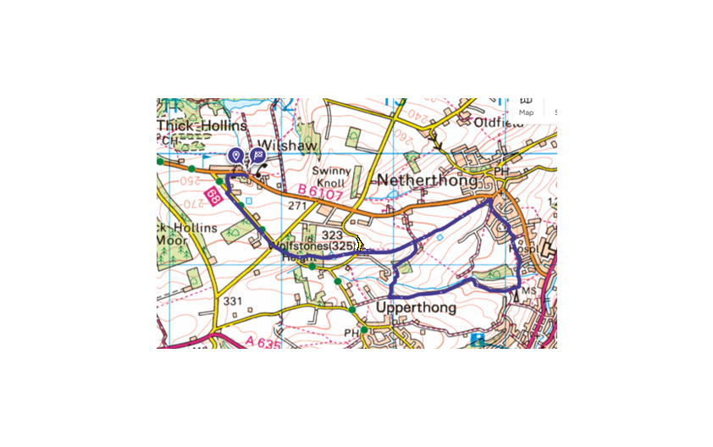
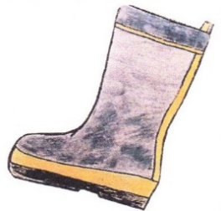
Wilshaw’s 5th Welly Walk - April 26 2026

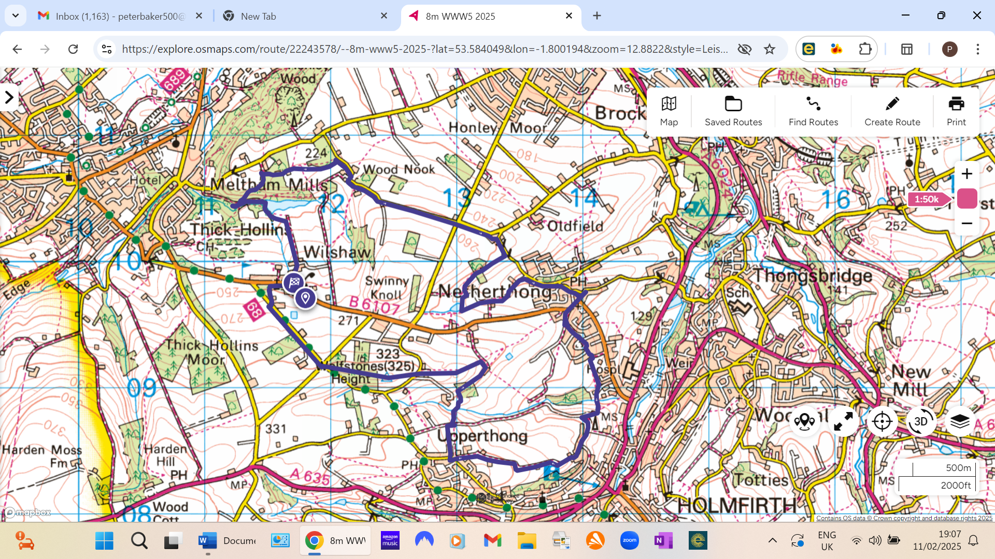
WWW 5 Miles Route Red and Black Text WWW 7.3 miles Route Red and Blue Text

EVERYONE: Start at the Village Hall (Built 1873 at a cost of £1200). Walk down through the village along Wilshaw Road until you reach the Church of St Mary the Virgin (built 1863). Go through the gates and keep right through the church gardens and then left up (the avenue) past the Almshouses (Built 1870 in memory of the daughter of Joseph and Eleanor Hirst, who were Wilshaw millowners). Join Wilshaw Mill Road (nothing now remains of the old Wilshaw Mill) and follow uphill to the crossroads. Cross the road and enter the wood through the small style on the corner. (Note this is a concessionary path and not a public footpath). Keep right following the main footpath climbing steadily through the wood. The path eventually crosses a private field to a lovely memorial to young Alfie. Cross over a broken-down wall to the Trig point (1061ft above sea level) where you should enjoy lovely panoramic views. From the Trig point follow the path downhill, cross the road and follow the footpath sign straight down the drive opposite. Follow the footpath for a few hundred yards, over a style and then through a large field keeping to the wall on your right. Turn right onto a farm track and then 50 metres before the farm turn right into the field and follow a faint path along the top side of the shrubs and through a wood. Follow the path down the hillside, through some gates, following any public footpath signs, over a small stream and then steeply up an old path until you reach a track (Back lane).
Choose one of the following options:
a) Slightly longer easier and more social walking option: (muddy in wet weather.) Turn right, up, Back Lane for about 50m and then take the 1stfootpath on your left over some stone steps towards Upperthong. The path crosses a field and then passes in front of some houses to a road junction. Turn left here, down Hill Lane, for over half a mile into Hill and eventually into Holt Lane which is the top side of Holmfirth. Follow the road round past the top end of Cooper Lane and past a radio mast. The road will eventually become a track again and after about 200 m past the radio mast look for a brown upright footpath marker post with an old footpath down to the right with stone walls either side. Note: Do not take an earlier path on the right down into Holmfirth.
b) Slightly shorter narrower, option: Turn left and follow this stony path downhill to the bottom. Do not cross the stream (on your left) follow it round a few bends and just follow the path uphill again. As soon as the track levels look for the old public path downhill to your left with stone walls either side identified by a tall brown signpost.
EVERYONE: The above options meet here again. Follow this old path, with walls either side, downhill until you reach another path to the left which also has walls at either side. Take this old path down and across a bridge at the bottom. Look carefully through the bushes at the bottom for the old series of Victorian (swimming?) pools on the right that resemble canal locks once owned by the family of David Brown, (tractors). Follow this path uphill, looking out for deer, and eventually left into Netherfields Estate. Continue across the right-hand edge of the Oval grassed area and pick up the path again to the right of No137. The tarmac path passes a series of spring fed old stone troughs as it enters the old village of Netherthong. Keep right until you reach the main road through the village.
5 Miles Route ONLY: Very carefully walk left up the road for a few yards and enter the small Cul de sac on the left. A footpath will be found between the houses towards the top of the Cul de sac. Follow this path through a large field which is usually planted with Maize or Oilseed Rape. This path will eventually cross the farm track you will remember from earlier in the walk and you now just retrace your steps uphill past the trig point and all the way back to the Village Hall for some well-earned refreshments.
7.3 Miles Route ONLY: Carefully cross the road and follow the footpath into the village. Pass the shop opposite the church and follow the road branching left just past the war memorial. Take the next left, before the pub, and you will pass the former post office (No 15), once a regular feature in ‘Last of the Summer Wine.’ Continue downhill past a few road junctions onto Miry Lane and, just as it starts to climb, take the footpath signed to the left. Follow this path, eventually along the side of a small babbling brook for about a quarter of a mile. At the end follow the footpath signs into a field on your left. Walk to the right up the field keeping the brook close to your right. At the end of the field ignore the stile straight in front of you and take the footpath to your right, across the brook, through a narrow gate and across a field towards some old stone cottages and farm buildings. Just before you reach the buildings follow the permissive footpath signs to the right for a short distance and then to the left, crossing the lane and through a gate between the buildings. Notice the old ponds on your right as you follow the path. Follow the path through woodland, then a large field and turn left when you reach the country road (Miry Lane). Follow uphill into Oldfield and turn left up a short grassy track between the houses and onto a level country lane towards and straight across Bradshaw Road continue straight and follow the lane towards and then through Wood Nook. A few hundred yards after the hamlet take a public footpath signposted to your left and follow the track keeping left though a wood, continue straight through a field, ignoring the first stone stile and over a stone stile in the corner of the field. Pass a few cottages to your left and follow a private lane for a few hundred yards until it reaches a farm. Just before the first grey farm building turn left following a path into the wood. This area is regularly used by downhill mountain bikers. Keep following the path to the right, you will see several paths with jumps etc but the right hand path is the gentlest and safest way down. At the bottom the path meets a cinder lane. Turn left up to Meltham Mills reservoir aka Windy Bank reservoir built 1805 and cross the embankment. Please be considerate to any fishermen as this is their club and they have paid to fish there. Follow the path slightly left after the bridge, over a few stone stiles, through the golf course then uphill into Manor Farm. Take the track to the right through Lower Greave to Wilshaw Road. Cross the road and follow left to the Village Hall and some well-earned refreshments.

